Resume

Full name | Anara Dzhumabaeva Emilbekovna 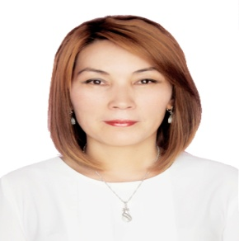  Married,2 children  02.06.1983  Tuleiken 1-82;Osh;Kyrgyzstan  Akademka.kg@gmail.com  0778 09 04 59
Position | Lecturer of the Department of American studies and Translation
Educational background | 1.Higher, Osh State University.The faculty of world languages,Major: English language teacher 2000-2005  2. Osh State University. The faculty of world languages. A student of a master degree 2017-2019  3.Osh State University. Department of science. A graduate student 2019..
Work experience | 2005-2007 An instructor of English .Osh State University .Faculty of world languages.  2007-2009A teacher of English at school: Nookat region.  2012-2013 An instructor of English .International University of Kyrgyzstan  2014-2017 Education Center «Hightime»  2017…. Education Center “Academka”  A founder of Education Center “Academka”  2019..Lecturer of the Department of American studies and Translation
Research activities in substantive and related fields | The comparative typology of enriching the vocabulary of the English and Turkish languages Osh SU2005  “The role of communicative method of teaching at secondary schools”.Vestnik Osh SU, 2018  «Global science innovation» International scientific-practical conference,Nus-Sultan ,March,2020.  » International scientific-practical conference «Science and education in the modern world» Каzakhstan, April,2020.  «Intelligence and Intellectual activity » Global science and innovation 2020:Central Asia» Nur-Sultan,Kz.  “Interrelation of mind and creativity”«One world-many cultures» IUK,Bishkek 2020.
Membership in the scientific and professional societies | 200Member of the English Language Teachers Association  TESOL  Alumnus of OPEN
Professional development | «Critical thinking» 2005
 | «Young leaders Forum» 2006
 | Scientific Methodological Conference 2007
 | TOEFL TIPS 2017
 | «Sustainable development in Education» 2018
 | “How to do research work” 2018
 | “Advanced General English” 2019
Oxford Teacher training seminar 2019
PRE-CELTA course 2019
Gamification webinar
Writing and reading strategies for IELTS seminar 2020
Academic writing seminar 2020
TECMUGALIM 2020
OPEN,US,Washington University-2021
MOOC-2021
Cambridge,Oxford,Edupress-2021
Media Literacy-2021

Languages skills: | Kyrgyz-native  Russian-advanced  Uzbek-advanced  English-fluently  French-basic  German-basic
Hobby: Traveling, reading, Internet,driving  Personal features: Responsible, punctual, communicative, industrious, optimist | Hobby: Trainings ,coaching  Personal features: Responsible, punctual, communicative, industrious, optimist,a good team player

