AUTOBIOGRAPHY
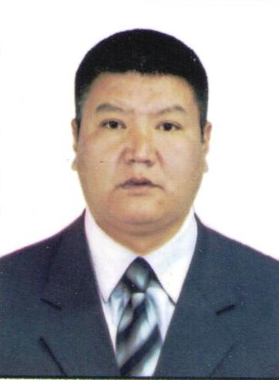

Name: Kursanbek
Surname: Jusupaliev
Address: Ak-Tilek Street 24/31
714007, Osh, Kyrgyzstan
Tel: +996 (779) 01-34-76
+996(551) 80-80-75
E-mail: kursanbek.7575@gmail.com
Born: 1975.18.05.
Family: Married, three children
Nation: Kyrgyz
Profession: German teacher
Education:
(1982-1992) School “M/Kalinin” in Nookat
district.
(1992-1997) Osh State University, Faculty of World Languages
German (+English) language.
(1997-1999) Kyrgyz National State University, Juridical
faculty.
Place of work:
(1997-1999) School “M/Kalinin” in Nookat
district.
(1999-2004) International University of Kyrgyzstan, Osh
Branch.
(2003-2006) Technological University in Osh.
(2017-till today) Osh State University, Faculty of World Languages
German language.
(2010-2017) Manager of the company for the production of
plastic windows and doors
Languages: Kyrgyz (mother language)
Russian
German
English

