Alimova Nurgul Abdyashymovna

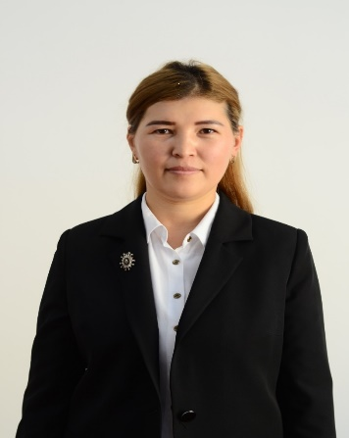 |  |  |  |  | - Alimova Nurgul Abdyashymovna, 1992 years old, Kyrgyz.  - In 2016, she graduated from Osh State University, Faculty of General Medicine, specialty "General Medicine" in Osh.  - In 2016, she entered South Branch of Kyrgyz Republic State Medical Institute of Post Graduate and Continues Education named after S. B. Daniyarov for residency in the specialty “Physician”.  - In 2019, she completed retraining (primary specialization) in the specialty "Pediatrics". South Branch of Kyrgyz Republic State Medical Institute of Post Graduate and Continues Education named after S. B. Daniyarov .Osh
Personal Information
Last Name |  |  |  | Alimova
Name |  |  |  | Nurgul
Middle name |  |  |  | Abdyashymovna
Date of birth |  |  |  | March 1, 1992
Contact information: |  |  | Home address |  |  |  |  | Osh city, Kasymova Street 309, № 41
 |  |  | Home phone number |  |  |  |  | +996701218068
 |  |  | Mobile phone |  |  |  |  | +996701218068
 |  |  | Fax
 |  |  | number E-mail |  |  |  |  | nurgul01031992@gmail.com
EDUCATION:
Start / End Date |  | Higher education institution |  |  |  | Faculty |  |  |  | Specialty
2010/2016 |  | Osh State University |  |  |  | Medical faculty |  |  |  | General Medicine
2016-2018 |  | Clinical internship |  |  |  | at Osh District Hospital |  |  |  | Physician
2019-2020 |  | Primary specialization in pediatrics |  |  |  | at Osh Children's Hospital |  |  |  | Pediatrician
Key qualifications/ EXPERIENCE in the field of accreditation and quality assurance (training, seminars, conferences, etc.).
Date |  | Name
2016 |  | Diploma -for the end of OshSU, specialty "General Medicine"
2018 |  | Certificate -for the completion of the resident physician
2019-2020 |  | Certificate- Certificate of advanced training in the course "Pediatrics" ,Primary specialization.
2017-2018 |  | Certificate–for the completion of English language courses "Upper Intermediate" level in the training center
2020 |  | Certificate- “Fundamentals of pedagogy of psychology”
2021 |  | Certificate- “Clinical immunology , allergology and infectology”
2021 |  | Certificate- “Modern means of electronic education”
Work experience
-2017-2018-resident doctor, Osh Interregional Joint Clinical Hospital, Osh
-2017-2018 –Laboratory assistant of the Department of "Faculty Surgery", Medical Faculty, OshSU
-2019- Pediatrician at the Osh Interregional Children's Clinical Hospital
-From 02.09.2019-pediatric teacher of the Department of "Clinical Disciplines 2" IMF, OshSU

Language proficiency: indicate competencies on a scale from 1 to 5 (1-excellentknowledge, 5-knowledge of the basic basics)
Language (Language) | Reading |  |  |  |  |  | Speaking |  | Writing
Kyrgyz | 1 |  |  |  |  |  | 1 |  | 1
Russian | 1 |  |  |  |  |  | 2-3 |  | 2-3
English | 1 |  |  |  |  |  | 2-3 |  | 2-3
Additional information
Marital status | married, 3 children
Personal qualities | responsible, punctual, purposeful
PC: | MS Word, Excel, Internet Explorer and other office programs

