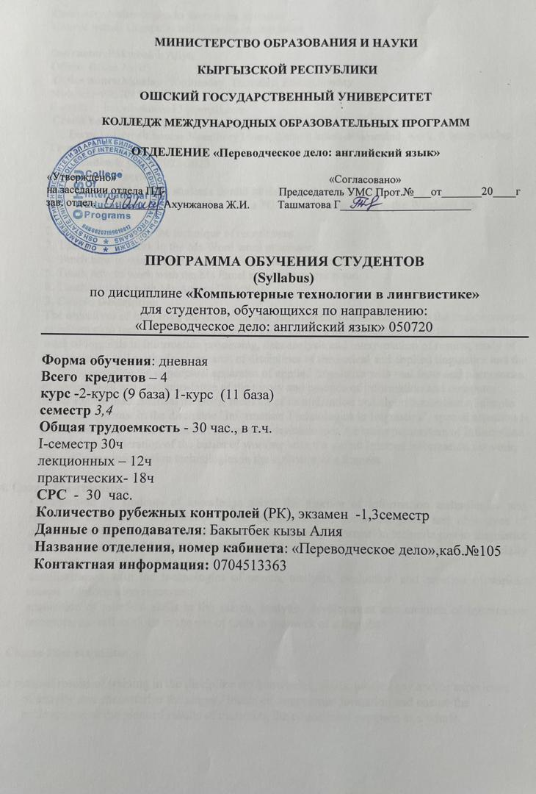

Computer technologies in linguistics Syllabus
Course name: Computer technologies in linguistics

Instructor:Bakytbek k Aliya
Office: Room №105
Office hours:Monday .Wednesday, Thursday, Friday,Sunday
Mobile: +996704513363
E-mail: bakytbekovaa13@gmail.com
Credit hours: (30: 12 practical classes, 18indep. classes)
Term 1: 1.credit hours- 30auditory hours, 2.credit hours-30hoursind. work, 8 hours testing.
Terms: I, II
Academic year: 2022-2023
2 . Course Objectives
By the end of the course, students should be able to:
1. Master the techniques of working with a PC. Teach how to work in the Windows OS environment.
2. Master the skills in the technique of recruitment.
3. Teach how to work in the Ms Word word processor.
4. Teach how to work in the Ms PowerPoint presentation editor.
5. Teach how to work with the Ms Excel spreadsheet processor.
6. Teach working with Ms Access DBMS
3. Course Description
The objectives of mastering the discipline are: familiarization of students with the basic concepts of information technology; development of tools and information technologies that support the work of linguists in information processing, data analysis and interpretation of results; study of the apparatus and methods of research of disciplines of theoretical and applied linguistics and the ability to correlate the conceptual apparatus of applied linguistics with real facts and phenomena of professional activity; knowledge of the theory and practice of information and computer technologies, mathematical methods, methods of formalization and algorithmization of simple linguistic systems. In the discipline "Information Technologies in linguistics", special attention is paid to the study of the essence of information technologies, the main parameters of information resources, consideration of the basics of working with the global Internet information network, ways of using information technologies in the activities of a linguist
4. Course Pre-requisites
• acquisition by students of knowledge about the essence of information technologies and resources, about their significance in the modern world, about the goals and objectives of obtaining and using information, about the basics of using information technologies in linguistics and the current state of the level and direction of development of applied software in the specialty of linguist;
familiarization with the technologies of search, analysis, evaluation and creation of various classes of information resources;
acquisition of practical skills in the search, analysis, development and creation of information resources, as well as skills in the use of tools in the work of a linguist.
5. Course Post-requisites
The planned results of training in the discipline are knowledge, skills, proficiency and/or experience of activity that characterize the stages / levels of competence formation and ensure the achievement of the planned results of mastering the educational program as a whole.

6.Технологическая кaрта дисциплины
I семестр
ТК | Разделы № и название темы | Количество часов | Сем | СРС | баллы | Общее количество компетенций | РК  10
Модуль 1
ТК 1 | Тема 1 | 2 | 2 | 2 | 0,3 | 1
 | Тема 2 | 2 | 2 | 2 | 0,3 | 1
ТК 2 | Тема 3 | 2 | 2 | 2 | 0,3 | 1
 | Тема 4 | 2 | 2 | 2 | 0,3 | 1
 | Тема 5 | 2 | 2 | 2 | 0,3 | 1
ТК 3 | Тема 6 | 2 | 1,5 | 2 | 1.5 | 1
 | Тема 7 | 2 | 1,5 | 2 | 1 | 1
 | Тема 8 | 2 | 2 | 2 | 1 | 1
Модуль1 | Всего | 16 | 15 | 16 | 5 | 1
Модуль 2 |  |  |  |  |  |  | РК  10
ТК 4 | Тема 9 | 2 | 2 | 2 | 0,3 | 1
 | Тема 10 | 2 | 2 | 2 | 0,3 | 1
ТК 5 | Тема 11 | 2 | 2 | 2 | 0,3 | 1
 | Тема 12 | 2 | 2 | 2 | 0,3 | 1
 | Тема 13 | 2 | 2 | 2 | 0,3 | 1
ТК 6 | Тема 14 | 2 | 2,5 | 2 | 1.5 | 1
 | Тема 15 | 2 | 2,5 | 2 | 2 | 1
Модуль2 | Всего | 14 | 15 | 14 | 5 | 1

7. Карта накопления баллов по дисциплине
I семестр
Всего часов | Практ. (семин.) | СРС | Модуль 1 |  |  | Модуль 2 |  | Экз
 |  |  | Ауд.часы |  | СРС | Ауд.часы | СРС
 |  |  | Практика |  |  | Практика
30 | 30 |  | 16ч | 16ч |  | 14ч | 14ч
Баллы |  |  | 15б |  | 5б | 15б | 5б
Итого модулей |  |  | К1 =10+15+5=30б |  |  | К2 =10+15+5=30б |  | К1+К2= 30+30+40 = 100б

8. Карта компетенций дисциплины в разрезе тем (разделов)
Разделы и названия  темы | Кол-во  час. | Компетенции
 |  | ОК 5 | ПК14 |  | ДК3 | Σ общее количество компетенций
1 module
1.Computer technologies in linguistics  Text processing and its levels | 2ч | + |  |  | + | 2
2.Text processing and information technology. | 2ч | + | + |  | + | 3
3Psychological aspects of computerization in education | 2ч |  | + |  |  | 1
4.General principles of solving linguistic problems by modeling. The main stages of problem solving | 2ч | + | + |  |  | 2
5.Machine translation of texts. The need to create. Levels of automation of the translation process. Human participation in translation using MP. Principles of work, stages. | 2ч | + | + |  | + | 3
6.The Internet in the work of the translator. Opportunities, resources Ways and basic principles of improving the efficiency of Internet search | 2ч | + |  |  | + | 2
2 module
1.Computer technologies in linguistics  Text processing and its levels | 2ч | + |  |  | + | 2
2.Text processing and information technology. | 2ч |  | + |  | + | 2
3 Psychological aspects of computerization in education | 2ч | 2 |  |  |  | 1
4.General principles of solving linguistic problems by modeling. The main stages of problem solving | 2ч | + | + |  |  | 2
5.Machine translation of texts. The need to create. Levels of automation of the translation process. Human participation in translation using MP. Principles of work, stages. | 2ч | + |  | + | + | 3
6.The Internet in the work of the translator. Opportunities, resources Ways and basic principles of improving the efficiency of Internet search | 2ч | + |  | + | + | 3
7.Automatic reading of tests. Optical character recognition systems and their capabilities | 2ч | + |  | + | + | 3
8.Translation Memory. Objective necessity of creation.  The principle of operation. | 2ч | + |  | + | + | 3
9. The Internet in the work of the translator. Opportunities, resources | 2ч |  |  | + | + | 2
10. Test on Unit 1 | 2ч
11. Exam Skills Trainer | 2ч
30. Test on unit 3 | 2ч
Итого | 30
Всего | 30

9.Учебно-методическое обеспечение

1. Computer technologies in linguistics A.N.Malyavina

2. Computer technologies in linguistics A.V.Zubov

3. Computer technologies in linguistics L.Y.Shchipitsina

4.A.S.Sookyan “Exercises in Modern English”

Internet Resourses:
1.https://dspace.tltsu.ru/bitstream/123456789/232/1/2%2021%2013%20%D0%9C%D0%B0%D0%BB%D1%8F%D0%B2%D0%B8%D0%BD%D0%B0%20%D0%90%D0%9D%20%D0%98%D0%A2%20%D0%B2%20%D0%BB%D0%B8%D0%BD%D0%B3%D0%B2%D0%B8%D1%81%D1%82%D0%B8%D0%BA%D0%B5.pdf
2.http://www.enotes.com/odp-encyclopedia/
3.http://academia-moscow.ru/ftp_share/_books/fragments/fragment_19425.pdf
4.https://www.studmed.ru/zubov-av-zubova-ii-informacionnye-tehnologii-v-lingvistike_df63dadef43.html
5.https://www.calameo.com/books/006676453258045e5bcb1
6.https://www.labirint.ru/books/510128/
7..YouTube

10. Информация по оценке
Рейтинг (баллы) | Оценка по буквенной системе | Цифровой эквивалент оценки | Оценка по традиционной системе
87 – 100 | А | 4,0 | Отлично
80 – 86 | В | 3,33 | Хорошо
74 – 79 | С | 3,0
68 -73 | D | 2,33 | Удовлетворительно
61 – 67 | Е | 2,0
31-60 | FX | 0 | Неудовлетворительно
Политик курса
• Не опаздывать на занятие
• Не разговаривать во время занятий, не жевать резинку
• Отключить сотовый телефон или переставить на беззвучный режим
• Не пропускать занятия, в случае болезни предоставить справку
• Пропущенные занятия отрабатывать в отведенное

11. Политика выставление баллов
В соответствии с картой накопления баллов, студент может набирать баллы по всем видам занятий. На практических занятиях за квизы, диктант, выполнение упражнений, сочинений, конспектов студенты могут получить максимум 10 баллов; за выполнение домашних заданий, эссе, презентации, топики, а также за внеаудиторную работу получают максимум 10 баллов; за рубежный контроль – максимум 40 балл
Информация об оценке

Рейтинг  (баллы) | Оценка по буквенной системе | Цифровой эквивалент оценки | Оценка по традиционной системе
87 – 100 | A | 5 | Отлично
74 -86 | B | 4 | Хорошо
61 – 73 | C | 3 | Удовлетворительно
31 – 60 | D | 2 | Неудовлетворительно

Выставление оценок осуществляется на основе принципов объективности, справедливости, всестороннего анализа качества знаний студентов, и других положений, способствующих повышению надежности оценки знаний обучающихся и устранению субъективных факторов.

