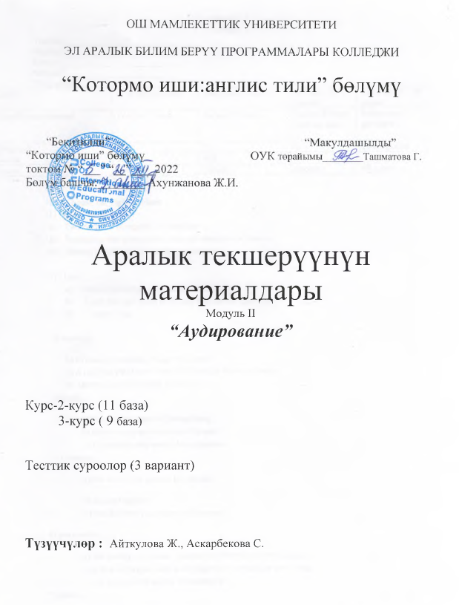

Module 2
Variant 1
Teacher:________________________
Student:_________________________
Group:__________________________
Subject:_________________________
Total scores:_______
Levels | 1st level-0,1scores | 2nd level-1 scores | 3rd level-2 scores | Total score – 10 scores
Количество заданий | For the 1st task | for the 2nd task | for the 3rd task  writing task | Задания по уровням
Вопросы | 10 | 5 | 6 | 21 вопросов
Баллы | 0,1 | 0.6 | 2
Итого: | 1score | 3scores | 6scores | 10 scores

- Choose the right variant
- Combination ….
- Two or more things joined together
- Something that you need or that you must do or have to.
- Simple, including only what is necessary

- Die …
- Simple, including only what is necessary
- A job that you learn to do and then do for many years.
- To stop living

3) increase …
a) to make something bigger or more
b) A job that you learn to do and then do for many years.
c) able to plan your work or life well
4) cells…..
a) the smallest parts of living thing
b) able to plan your work or life well
c) A person who works for someone
5) connect…
a) the work that you do for money
b) to join together
c) the job that you do to earn money
6) personality …..
a) the quality that make a person different from other people
b) group of people who work together to make or sell things
c) A person who works for someone
7) grab …..
a) Simple, including only what is necessary
b) to take hold of something suddenly
c) a job that you learn to do and then do for many years

8) diving …..
a) jumping head first into water
b) group of people who work together to make or sell things
c) a job that you learn to do and then do for many years

9) advertising …..
a) to finish your studies at a school, college or university
b) group of people who work together to make or sell things
c) telling people about things to buy
10) weaker…..
a) the main subject that you study in college
b) group of people who work together to make or sell things
c) less strong
2. Give the definitions of the following words
1.avoid ….

2. complex…

3.confused…..

4.creative….

5.difficulty…

3.listen to the audio and choose the correct answers.
1.The presenter says its important to avoid (stress| sweets| salmon)
2. Brain-power foods can help us feel (sleepy| warm | happy)
3. A type of (salt| sugar | fat)in fish is good for the brain.
4. if you often forget things eat more (blueberries| bread |broccoli).
5. vitamin (B| C| E) is very important for older people because it keeps the brain young.
6. The presenter says that a combination of brain-power foods (rest | exercise| work) is the key to good brain health.
Module 2
Variant 2
Teacher:________________________
Student:_________________________
Group:__________________________
Subject:_________________________
Total scores:_______
Levels | 1st level-0,1scores | 2nd level-1 scores | 3rd level-2 scores | Total score – 10 scores
Количество заданий | For the 1st task | for the 2nd task | for the 3rd task  writing task | Задания по уровням
Вопросы | 10 | 5 | 6 | 21 вопросов
Баллы | 0,1 | 0.6 | 2
Итого: | 1score | 3scores | 6scores | 10 scores

- Choose the right variant
1)unique ….
a) a special piece of paper you fill out when you try to get a job
b) different unlike anything else.
c) a person who helps someone in a more important position

2 ) Dangerous …
- May hurt you
- A job that you learn to do and then do for many years.
- The person who controls a company or business

3) Destroy …
a) to break or ruin something
b) A job that you learn to do and then do for many years.
c) able to plan your work or life well
4) insect …..
a) a small animal with six legs such as an ant or a fly
b) able to plan your work or life well
c) A person who works for someone
5) pollution …
a) the work that you do for money
b) dirty air or water
c) the job that you do to earn money
6) local …..
a) of a place near you
b) group of people who work together to make or sell things
c) A person who works for someone
7) tourist …..
a) Simple, including only what is necessary
b) a person who visits a place on vacation
c) a job that you learn to do and then do for many years

8) graduate …..
a) to finish your studies at a school, college or university
b) group of people who work together to make or sell things
c) a job that you learn to do and then do for many years

9) advertising …..
a) to finish your studies at a school, college or university
b) group of people who work together to make or sell things
c) telling people about things to buy
10) shake …..
a) the main subject that you study in college
b) to move quickly up and down or from side to side
c) telling people about things to buy
2. Give the definitions of the following words
1. volunteer ….

2. pretty…

3. population…..

4.ancient ….

5.repair …
3.listen to the audio and choose the correct answers.
1.The presenter says its important to avoid (stress| sweets| salmon)
2. Brain-power foods can help us feel (sleepy| warm | happy)
3. A type of (salt| sugar | fat)in fish is good for the brain.
4. if you often forget things eat more (blueberries| bread |broccoli).
5. vitamin (B| C| E) is very important for older people because it keeps the brain young.
6. The presenter says that a combination of brain-power foods (rest | exercise| work) is the key to good brain health.
Module 2
Variant 3
Teacher:________________________
Student:_________________________
Group:__________________________
Subject:_________________________
Total scores:_______
Levels | 1st level-0,1scores | 2nd level-1 scores | 3rd level-2 scores | Total score – 10 scores
Количество заданий | For the 1st task | for the 2nd task | for the 3rd task  writing task | Задания по уровням
Вопросы | 10 | 5 | 6 | 21 вопросов
Баллы | 0,1 | 0.6 | 2
Итого: | 1score | 3scores | 6scores | - scores

1.Choose the right variant

1) understand …
a) a special piece of paper you fill out when you try to get a job
b) A job that you learn to do and then do for many years.
c) to know what something means or why something happens

2) debate …
a) formal discussion of an issue
b) A job that you learn to do and then do for many years.
c) able to plan your work or life well
3) wrong …
- not correct not as it should be
- A job that you learn to do and then do for many years.
- A paper you get when you finish college
4) emotion …..
a) Simple, including only what is necessary
b) feelings
c) A person who works for someone
5) describe …
a) to explain
b) Simple, including only what is necessary
c) the job that you do to earn money
6) facial …..
a) the look on your face that shows how you feel
b) group of people who work together to make or sell things
c) A person who works for someone
7) career …..
a) Simple, including only what is necessary
b) group of people who work together to make or sell things
c) a job that you learn to do and then do for many years
8) skill …..
a) the ability to do something well
b) group of people who work together to make or sell things
c) a job that you learn to do and then do for many years
9) advertising …..
a) to finish your studies at a school, college or university
b) group of people who work together to make or sell things
c) telling people about things to buy
10) afraid …..
a) feeling fear
b) group of people who work together to make or sell things
c) telling people about things to buy
2. Give the definitions of the following words
1.traditional ….

2. exiting …

3.improve …..

4.active ….

5.reaction…
3.listen to the audio and choose the correct answers.
1.The presenter says its important to avoid (stress| sweets| salmon)
2. Brain-power foods can help us feel (sleepy| warm | happy)
3. A type of (salt| sugar | fat)in fish is good for the brain.
4. if you often forget things eat more (blueberries| bread |broccoli).
5. vitamin (B| C| E) is very important for older people because it keeps the brain young.
6. The presenter says that a combination of brain-power foods (rest | exercise| work) is the key to good brain health.

