Module I Variant I For each right answer – 0,4 score
Group___________________________ for the 1st task – 2 score
Student________________________________________ for the 2nd task –2score
Teacher________________________________________ for the 3rd task – 6 score
All in all: 10 scores
1 .Listening
Circle the numbers and measurements you hear

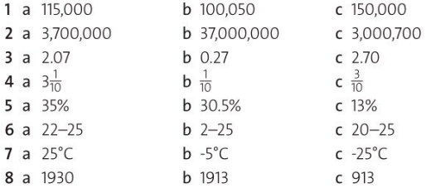

2. Vocabulary. Write the parts of body according to the numbers.

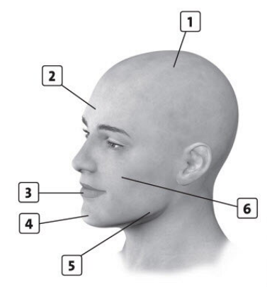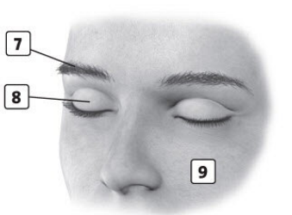

______________________________________________________________________________________________________________________________________________________________________________________________________________________________________________________________________________________________________________________________________________________________________________________________________________________________________________________________________________

3. Speaking .
Read the text and retell.
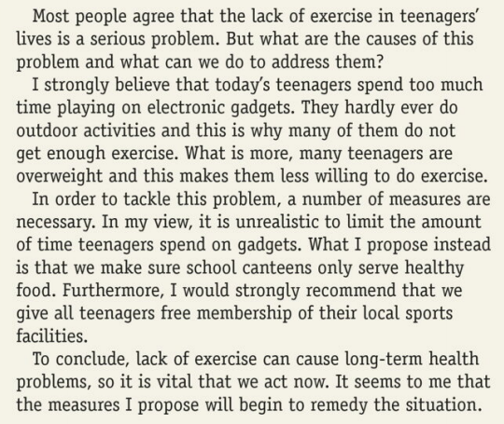

Module I Variant II For each right answer – 0,4 score
Group___________________________ for the 1st task – 2 score
Student________________________________________ for the 2nd task –2score
Teacher________________________________________ for the 3rd task – 6 score
All in all: 10 scores

1 .Listening
Circle the numbers and measurements you hear

2. Vocabulary. Write the parts of body according to the numbers.

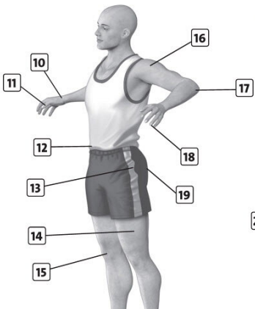
______________________________________________________________________________________________________________________________________________________________________________________________________________________________________________________________________________________________________________________________________________________________________________________________________________________________________________________________________________

3. Speaking .
Read the text and retell.
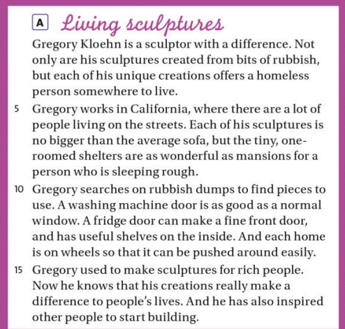

Module I Variant III For each right answer – 0,4 score
Group___________________________ for the 1st task – 2 score
Student________________________________________ for the 2nd task –2score
Teacher________________________________________ for the 3rd task – 6 score
All in all: 10 scores

1 .Listening
Circle the numbers and measurements you hear

2. Vocabulary. Write the parts of body according to the numbers.

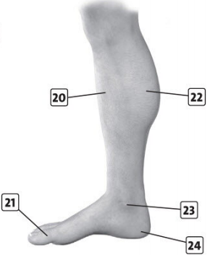
______________________________________________________________________________________________________________________________________________________________________________________________________________________________________________________________________________________________________________________________________________________________________________________________________________________________________________________________________________

3. Speaking .
Read the text and retell.
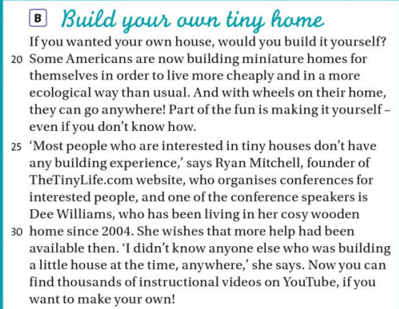

Module I Variant IV For each right answer – 0,4 score
Group___________________________ for the 1st task – 2 score
Student________________________________________ for the 2nd task –2score
Teacher________________________________________ for the 3rd task – 6 score
All in all: 10 scores

1 .Listening
Circle the numbers and measurements you hear

2. Grammar

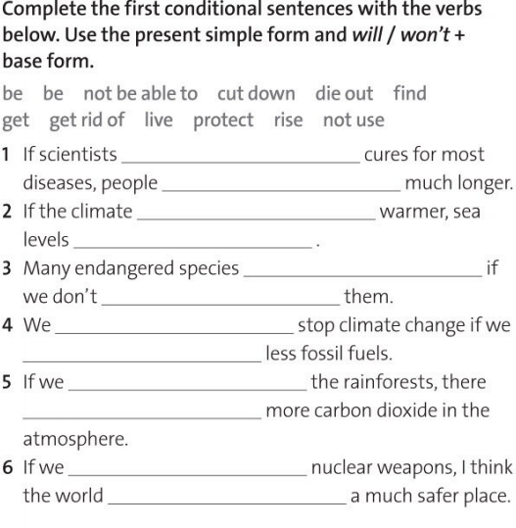

3. Speaking.
Read the text and retell.

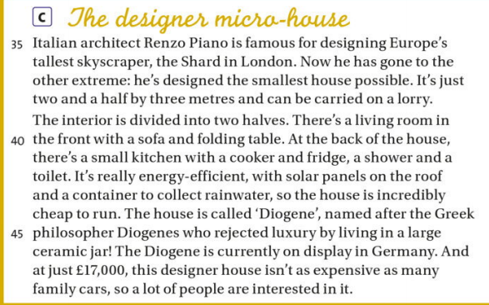

Module I Variant V For each right answer – 0,4 score
Group___________________________ for the 1st task – 2 score
Student________________________________________ for the 2nd task –2score
Teacher________________________________________ for the 3rd task – 6 score
All in all: 10 scores

1 .Listening
Circle the numbers and measurements you hear

2. Vocabulary.
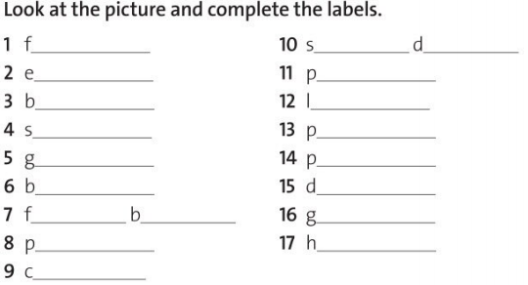

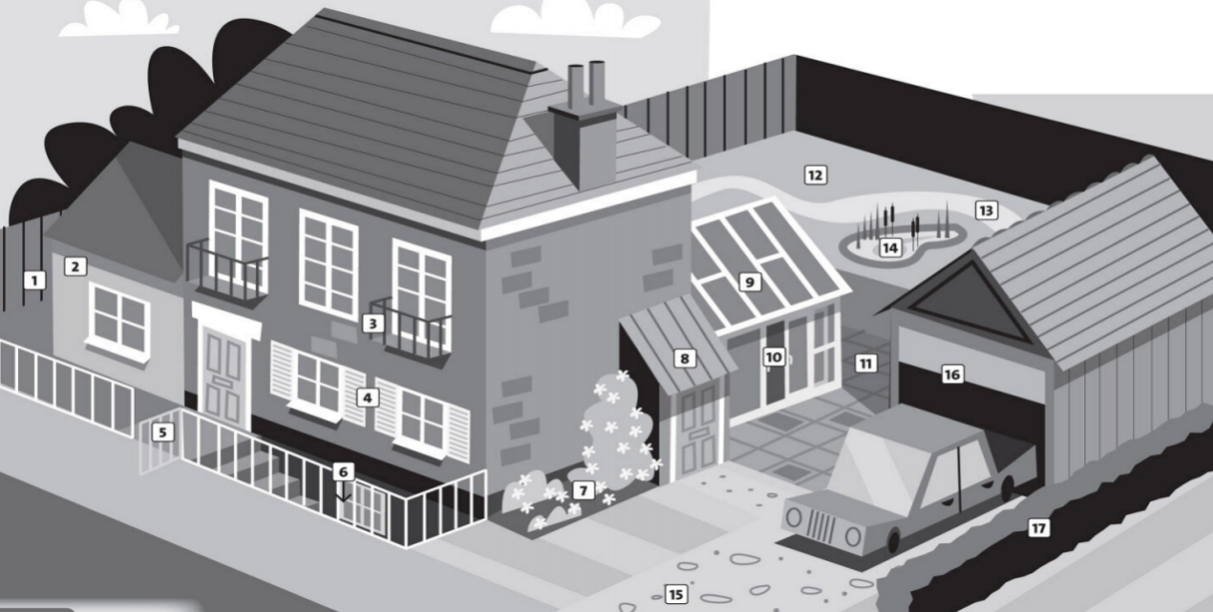

3. Speaking.
Read the text and retell.

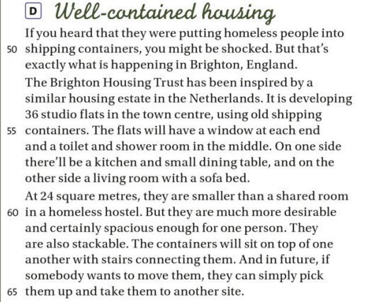

Variant I key
1. | c | a | a | c | b | c | c | a
2. | scalp | forehead | lip | chin | jaw | cheek | eyebrow | eyelid | skin
Variant II key
1. | c | a | a | c | b | c | c | a
2. | wrist | thumb | waist | hip | thigh | knee | shoulder | elbow | nail | bottom
Variant III key
1. | c | a | a | c | b | c | c | a
2. | scalp | forehead | lip | chin | jaw | cheek | shin | toe | calf | ankle | heel
Variant IV key
1. | c | a | a | c | b | c | c | a
2. | find, will live | gets, will rise | will die out, protect | won’t be able to, don’t use | cut down, will be | get rid of, will be
Variant V key
1. | c | a | a | c | b | c | c | a
2. | fence | extension | balcony | shutters | gate | basement | flower bed | porch | conservatory | sliding doors | patio | lawn | path | pond
15 drive 16 garage 17 hedge

