Module II Variant I Group_______________________________________ for the 1st task – 3 score
Student________________________________________ for the 2nd task -3 score
Teacher________________________________________ for the 3rd task – 4 score
All in all: 10scores
1.Grammaг
Complete the sentence with the past continuous form of the verb in bracket.
1) Yesterday at p.m. we ____________(have) dinner
a) have c)will have
b) had d) were having
2) My eyes were closed, but I_______________(not sleep).
) don’t sleep c)wasn’t sleeping
b) sleeping d) was sleep
Choose the correct past continuous and past simple forms to complete the sentences below.
3) He ____________very fast when the police __________him.1.won't / doesn't
a) was driving c)was stopping
b) drove d) stopped
4. This morning I _______________and I ____________breakfast for everybody.
a) was getting up c)was making
b) got up d) made
5) Choose the correct option to complete the sentences below.
My teacher is very _______He speaks so slowly that we just want to sleep.
a) bored
b) boring
6) She was very ____________with him for not telling her the truth.
a) annoyed
b) annoying
7) Choose the correct forms, don’t have to, mustn’t, to complete the sentences below.
I ________________be late. It's the most important meeting of the year.
- mustn’t
- don’t have to
8) I ______________wear a tie; I do it because I like wearing ties.
- mustn’t
- don’t have to
9) You ________smoke in here; smoking is not allowed.
- mustn’t
- don’t have to
10)We _____________cook more; there's enough food.
- mustn’t
- don’t have to

2. Translate these words
- Action film-
- Horror film-
- Documentary-
- War film-
- Animation-
- Chat show-
- Comedy-
- Fantasy film-
- Exciting-
- Imagintive-
3. Read the text .

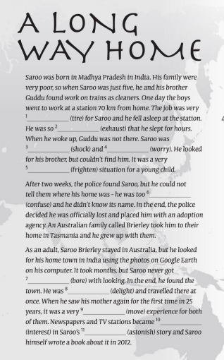

Module II Variant I Group_______________________________________ for the 1st task – 3 score
Student________________________________________ for the 2nd task -3 score
Teacher________________________________________ for the 3rd task – 4 score
All in all: 10 scores
1.Grammar
Choose the correct option to complete the sentences below.
1)My teacher is very _______He speaks so slowly that we just want to sleep.
a) bored
b) boring
2) She was very ____________with him for not telling her the truth.
a) annoyed
b) annoying
3) Choose the correct forms, don’t have to, mustn’t, to complete the sentences below.
I ________________be late. It's the most important meeting of the year.
- mustn’t
- don’t have to
4) I ______________wear a tie; I do it because I like wearing ties.
- mustn’t
- don’t have to
5) You ________smoke in here; smoking is not allowed.
- mustn’t
- don’t have to
6)We _____________cook more; there's enough food.
- mustn’t
- don’t have to
Complete the sentence with the past continuous form of the verb in bracket.
7) Yesterday at p.m. we ____________(have) dinner
a) have c)will have
b) had d) were having
8) My eyes were closed, but I_______________(not sleep).
) don’t sleep c)wasn’t sleeping
b) sleeping d) was sleep
Choose the correct past continuous and past simple forms to complete the sentences below.
9) He ____________very fast when the police __________him.1.won't / doesn't
a) was driving c)was stopping
b) drove d) stopped
10. This morning I _______________and I ____________breakfast for everybody.
a) was getting up c)was making
b) got up d) made

2. Translate these words
1.Cave
2.Cliff
3.Desert
4.Forest
5.Hill
6.Lake
7.Shallow
8.Deep
9.Narrow
10. Icy
3. Reading
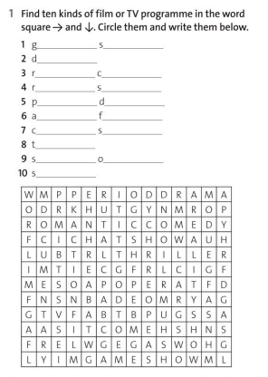
Module II Variant I Group_______________________________________ for the 1st task – 3 score
Student________________________________________ for the 2nd task -3 score
Teacher________________________________________ for the 3rd task – 4 score
All in all:10 scores
1.Grammaг
Complete the sentence with the past continuous form of the verb in bracket.
2) My eyes were closed, but I_______________(not sleep).
) don’t sleep c)wasn’t sleeping
b) sleeping d) was sleep
1) Yesterday at p.m. we ____________(have) dinner
a) have c)will have
b) had d) were having
Choose the correct past continuous and past simple forms to complete the sentences below.
3) He ____________very fast when the police __________him.1.won't / doesn't
a) was driving c)was stopping
b) drove d) stopped
4. This morning I _______________and I ____________breakfast for everybody.
a) was getting up c)was making
b) got up d) made
5) Choose the correct option to complete the sentences below.
My teacher is very _______He speaks so slowly that we just want to sleep.
a) bored
b) boring
6) She was very ____________with him for not telling her the truth.
a) annoyed
b) annoying
7) Choose the correct forms, don’t have to, mustn’t, to complete the sentences below.
I ________________be late. It's the most important meeting of the year.
- mustn’t
- don’t have to
8) I ______________wear a tie; I do it because I like wearing ties.
- mustn’t
- don’t have to
9) You ________smoke in here; smoking is not allowed.
- mustn’t
- don’t have to
10)We _____________cook more; there's enough food.
- mustn’t
- don’t have to

2. Translate these words

1.Angry
2.Bored
3.Calm
4. Excited
5.Nervous
6.Relaxed
7.Scared
8. Shocked
9.Describe
10.Life jacket

