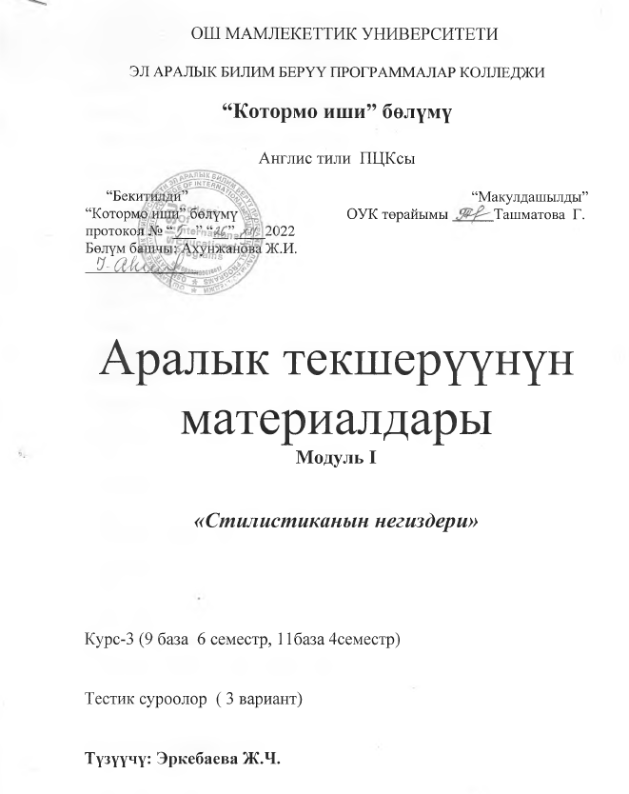

Module I Variant 1 For the 2nd and 3rd courses
Group:__________ For each right answer -3 score
Student :_____________________
Teacher: _____________________
1. Thou, thy, giveth, taketh, brethren are examples of:
A. Historical words
B. Archaic words proper
C. Morphological archaisms
D. Obsolete words
2. An example of a term is:
A. Feeler
B. Booze
C. Bastard
D. Subcutaneous
3. An example of a foreign word is:
A. Cri de couer
B. Albeit
C. Strabismus
D. Viejo
4.An example of metaphor is found in:
A. The maid was cleaning silver.
B. That’s a pretty kettle of fish!
C. There was a storm of indignation.
D. Even the chairs were bored.
5. An example of metonymic antonomasia is found in:
A. My dear Simplicity
B. Sir Something Somebody
C. What’s all this Tosca stuff about?
D. I’ve got a Burberry.
6. The steak looked back at him is a case of:
A. Metaphor
B. Personification
C. Periphrasis
D. Antonomasia
7.Dense anxiety and tense excitement is an example of:
A. Alliteration
B. Assonance
C. Onomatopoeia
D. Paronomasia
8. An example of multiplication is:
A. Difference
B. Laaaarge
C. SIR
D. Ref-use
9. The phrase “I don’t weally know” reflects:
A. Territorial status
B. Educational status
C. Speech deficiency
D. Tender age
10. Whats a matter, dunno, dullin are examples of:
A. Grammatical transposition
B. Permanent graphon
C. Cacophony
D. Sound-imitation

Module I Variant II For the 2nd and 3rd courses
Group:__________ For each right answer -3 score
Student :_____________________
Teacher: _____________________
1. An example of slang is:
A. Wee
B. Okie
C. Devil
D. Best bib and tucker
2. Bon mot is an example of:
A. A foreign word
B. A term
C. A historical word
D. A barbarism
3. The steak looked back at him is a case of:
A. Metaphor
B. Personification
C. Periphrasis
D. Antonomasia
4. An example of synecdoche is observed in:
A. She saw around her multitudes of red lips.
B. Two Van Dycks in this room.
C. Keep your eyes and ears open.
D. He made his way through perfume and conversation.
5. An example of professional jargon is:
A. Hillbilly
B. Walkie-talkie
C. Stomacher
D. Bona
6. The opposite sex is an example of:
A. Irony
B. Euphemism
C. Periphrasis
D. Metonymy
7. An example of irony is contained in:
A. His heart wasn’t in it.
B. Heavy traffic of three Fords
C. Hamlet of a fellow
D. Music was bellowing from the open door.
8. The sentence Drivers used the same qualitative word
can be rephrased as:
A. Drivers used the evaluative epithet in their speech.
B. Drivers used the slang word in their speech.
C. Drivers used the vulgarism in their speech.
D. Dr
9.An example of a foreign word is:
A. Cri de couer
B. Albeit
C. Strabismus
D. Viejo
10. An example of slang is:
A. Wee
B. Okie
C. Devil
D. Best bib and tuckerivers used the professional jargonism in their speech.ide

Module I Variant III For the 2nd and 3rd courses
Group:__________ For each right answer -3 score
Student :_____________________
1. Bon mot is an example of:
A. A foreign word
B. A term
C. A historical word
D. A barbarism
2. Lass is an example of:
A. A colloquial word
B. A slang word
C. Cockney dialect
D. Scottish dialect
3. An example of professional jargon is:
A. Hillbilly
B. Walkie-talkie
C. Stomacher
D. Bona fideTeacher: ___
4. The steak looked back at him is a case of:
A. Metaphor
B. Personification
C. Periphrasis
D. Antonomasia
5. An example of synecdoche is observed in:
A. She saw around her multitudes of red lips.
B. Two Van Dycks in this room.
C. Keep your eyes and ears open.
D. He made his way through perfume and conversation.
6. The opposite sex is an example of:
A. Irony
B. Euphemism
C. Periphrasis
D. Metonymy
7. An example of irony is contained in:
A. His heart wasn’t in it.
B. Heavy traffic of three Fords
C. Hamlet of a fellow
D. Music was bellowing fr
8. An example of professional jargon is:
A. Hillbilly
B. Walkie-talkie
C. Stomacher
D. Bona
9. The phrase “I don’t weally know” reflects:
A. Territorial status
B. Educational status
C. Speech deficiency
D. Tender age
10. Whatsamatter, dunno, dullin are examples of:
A. Grammatical transposition
B. Permanent graphon
C. Cacophony
D. Sound-imitationide

