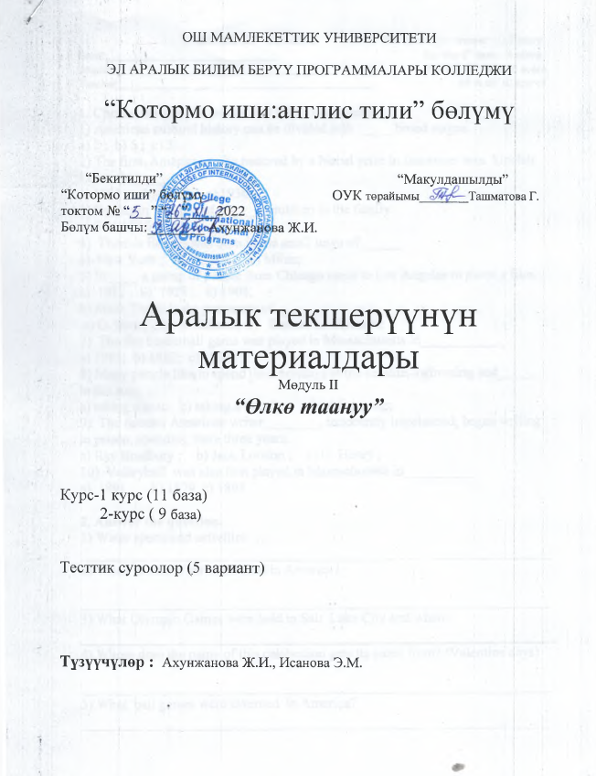

Module II Variant I For each right answer – 0,4 score
Group___________________________ for the 1st task – 4 score
Student________________________________________ for the 2nd task – 6 score
Teacher________________________________________ All in all: 10 scores
1. Choose the proper words and fill in the blanks.
1) American cultural history can be divided into _____ broad stages.
a) 2 ; b) 5 ; c) 3;
2) The first American to be honored by a Nobel prize in literature was Sinclair Lewis, in ________
a) 1931 ; b) 1923; c) 1930;
3) Benjamin was one of _______children in the family.
a) 5 ; b) 10 ; c) 17;
4) Thomas Edison was born in the small town of______
a) New York ; b) Boston ; c) Milan;
5) In ____ a group of people from Chicago came to Los Angeles to shoot a film.
a) 1912 ; b) 1928 ; c) 1908;
6) Mark Twain is the pen name of ______
a) O. Henry ; b) T. Edison; c) Samuel L. Clemens;
7) The firs basketball game was played in Massachusetts in____________
a) 1985; b) 1882; c) 1891;
8) Many people like to spend their holidays at the seaside, swimming and______ in the sun.
a) taking a seat; b) taking a breath; c) taking a nap;
9) The famous American writer________, innocently imprisoned, began writing in prison, spending there three years.
a) Ray Bradbury ; b) Jack London ; c) O. Henry ;
10) Volleyball was also first played in Massachusetts in__________
a) 1891 b) 1879 c) 1895

2. Answer the question.
1) Water sports and activities …..
__________________________________________________________________
2) When is New Year celebrated in America?

__________________________________________________________________
3) What Olympic Games were held in Salt Lake City and when?

4) Whom does the name of this celebration gets its name from? (Valentine days)

__________________________________________________________________
5) What ball games were invented in America? __________________________________________________________________

Module II Variant II For each right answer – 0,4 score
Group___________________________ for the 1st task – 4 score
Student________________________________________ for the 2nd task – 6 score
Teacher________________________________________ All in all: 10 scores

- Choose the proper words and fill in the blanks.

1) Mickey Mouse cartoons appeared in
a) 1927; b) 1930 ; c) 1928;
2) Henry Longfellow, one of the most famous American____________
a) actor; b) writer ; c) poet;
3) Who invented the game of basketball?
a) James Bon ; b) Michael Jordan ; c) James Naismith;
4) How is the game of baseball called in America?
a) Base ball; b) American ball; c) American game;
5) The five major American sports are volleyball, basketball, football, baseball and _______
a ) swimming ; b) tennis; c) hockey;
6) Hemingway was born in _____
a) Boston,1898 ; b ) Chicago,1988 ; c) Illinois, 1898 ;
7) Where and when was the first rodeo event held?
a) Arizona in 1898; b) Boston in 1888 ; c) of Prescott, Arizona in 1888;
8) Paramount Pictures was founded in __________
a) 1989; b) 1979; c) 1912;
9) Thomas Edison, the world’s leading inventor, patented over_____ inventions.
a) 100; b) 200; c) 1000;
10) Franklin was a talented _______.
a) poet; b) actor; c) diplomat;

2. Answer the question.
1) What kind of a holiday is Christmas?
_________________________________________________________________
2) When is St. Valentine’s Day celebrated?
__________________________________________________________________
3) What American Champions do you know? __________________________________________________________________
4) What are the most popular ball game?
__________________________________________________________________
5) How many books did Jack London write?

Module II Variant III For each right answer – 0,4 score
Group___________________________ for the 1st task – 4 score
Student________________________________________ for the 2nd task – 6 score
Teacher________________________________________ All in all: 10 scores

- Choose the proper words and fill in the blanks.
1. Where was J. London born?
a) in London ; b) in Boston; c) in San Francisco;
2. When was Memorial Day declared a national holiday in America?
a) in 1988; b) in 1809; c) in 1971;
3. The first American immigrants, beginning more than ______
a) 10,000 years ago; b)100 year ago; c) 20,000 years ago;
4) In ____ the first studio appeared in Hollywood, a part of Los Angeles.
a) 1908; b) 1927; c) 1911;
5) The first schools of landscape painting began to appear in America in _____
a) 1825; b)1908 ; c)1820;
6) Edison’s inventions was the _______
a) stove ; b) TV; c) electric lamp;
7) When did Bill Gates found Microsoft?
a) May 4,1978 ; b) April 4; 1976 ; c) April 4, 1975;
8) The word RODEO comes from the _____roader.
a) American ; b) Italian ; c) Spanish ;
9) The first Olympic Games took place in ____
a) 1800; b )907; c) 776;
10) The Liberty Bell was rung on_____
a) June 8, 1776; b) July 7, 1778; c) July 8, 1776;

2. Answer the question.
1) What do you remember about a “tea party”? __________________________________________________________________
2) Who were the first American immigrants?

3) What is the Great Seal of the USA ?
_________________________________________________________________

4) How did the American Thanksgiving holiday begin?
__________________________________________________________________
5) How do people celebrate Thanksgiving Day today?

Module II Variant IV For each right answer – 0,4 score
Group___________________________ for the 1st task – 4 score
Student________________________________________ for the 2nd task – 6 score
Teacher________________________________________ All in all: 10 scores

- Choose the proper words and fill in the blanks.
1. The Liberty Bell was cast in England in________
a) 1765 ; b) 1878; c)1752;
2. In what countries is baseball popular?
a) in USA; b) in GB; c) in Cuba;
3 . Henry Longfellow, one of the most famous American____________
a) actor; b) writer ; c) poet;
4. The first schools of landscape painting began to appear in America in _____.
a) 1920; b) 1912; c) 1820;
5. Mary Cassatt is the most popular woman t in the USA.
a) writer b) singer c) artist
6. The famous American writer ______was awarded the Nobel Prize.
a) Mark Twain; b) Jack London; c) Ernest Hemingway;
7. _______ presidents of the USA were graduates of Harvard.
a) 8; b)5; c) 7;
8. In _____ the first studio appeared in Hollywood.
a) 1922; b) 1981; c) 1911;
9. Benjamin West is an American Historical ______who worked in England.
a) writer; b ) singer; c) painter ;
10. What kind of a singer was Paul Robson?
a) tenor; b)baritone; c) bass;

2. Answer the question.
1) Where were the first American theatres built?
__________________________________________________________________
2) What is the native American music?

3) When and where will the next Olympic Games take place? __________________________________________________________________

4) What famous American film studios are known all over the world?
__________________________________________________________________
5) When was G. Bush elected President?
_____________________________________________________________________________

Module II Variant V For each right answer – 0,4 score
Group___________________________ for the 1st task – 4 score
Student________________________________________ for the 2nd task – 6 score
Teacher________________________________________ All in all: 10 scores

1.Choose the proper words and fill in the blanks.

1) What family was Martin Luther king born to?
a) into a black family in 1923; b) into a black family in 1925; c) into a black
family in 1929;
2) When Charlie Chaplin was five years old, he sang for his ______
a) brother; b) sister; c) mother;
3) Benjamin Franklin was journalist and ______
a) president; b) writer; c) inventor;
4) Basketball was also first played in Massachusetts in__________
a) 1891 b) 1879 c) 1895
5) Children enjoy to sing carols, recite poems and get presents on ________
a ) April Fool’s day; b) Christmas ; c) Halloween;
6) C. Columbus an….. sailor.
a) American; b) Iran; c) Italian;
7) Volleyball was also first played in Massachusetts in__________
a) 1891 b) 1879 c) 1895
8) The USA hosted Olympic summer and winter Games_______ times
a)3 ; b)4 ; c) 7 ;
9) What was O. Henry real name?
a) Jack Sidney Porter; b) William London Porter ; c) William Sidney Porter;
10) What prize was Hemingway awarded and when?
a) Award star,1878; b) Nobel star,1954; c) Nobel Prize ,1954;
2. Answer the question.
1) What American scientists were awarded the Nobel Prize? _________________________________________________________________
2) What names has the American flag?

__________________________________________________________________
3) What is the main mission of Microsoft?
__________________________________________________________________
4)What is his story “ The Old Man and the Sea” about?
__________________________________________________________________
5) What is the Great Seal of the US?

