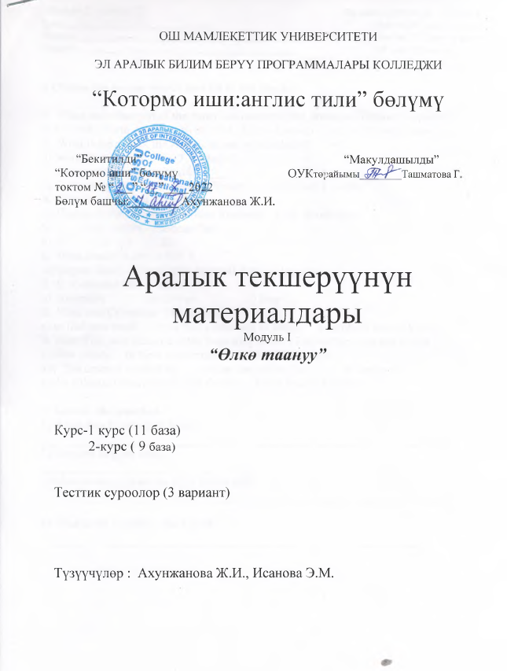

Module I Variant I For each right answer – 0,4 score
Group___________________________ for the 1st task – 4 score
Student________________________________________ for the 2nd task – 6 score
Teacher________________________________________ All in all: 10 scores

1.Choose the proper words and fill in the blanks.

1. When and what part of the American continent did Amerigo Vespucci explore?
a) In 1998 , North America b) In 1914 , South America c) In 1497,South America
2. What is the date of the American nation’s birthday?
a) November 4 b) June 3 c) July 4
3. Independence was written by ____
a) G. Washington b) Thomas Jefferson c) Abraham Lincoln
4. The first president of the USA______
a) Thomas Jefferson b) American Vespucci c) G. Washington .
5. ____ stars on the American flag.
a) 51 b) 50 c) 52
6. What kind of a city is NY ?
a) largest cities in the world .b) small city c) big city
7. C. Columbus an….. sailor.
a) American b) Italian. c) Iran
8. What was Columbus’ life dream?
a) to find new world b) to find a new way to India. c)to find a way to USA
9. New York was founded at the beginning of the 17-th century and was called___
a) New Jersey; b) New Amsterdam; c) New Hampshire
10. The country washed by…… in the east and by the …….. in the west
a) the Atlantic Ocean, the Pacific Ocean. b) the Pacific Ocean

2. Answer the question.
1) When was Elizabeth II born?
__________________________________________________________________
2) The first English king… __________________________________________________________________
3)What countries does the USA border on?
__________________________________________________________________

4) What is the climate in the USA? __________________________________________________________________

Module I Variant II For each right answer – 0,4 score
Group___________________________ for the 1st task – 4 score
Student________________________________________ for the 2nd task – 6 score
Teacher________________________________________ All in all: 10 scores

1.Choose the proper words and fill in the blanks.

1. Independence was written by ____
a) G. Washington b) Thomas Jefferson c) Abraham Lincoln
2. The first president of the USA______
a) Thomas Jefferson b) American Vespucci c) G. Washington
3. ____ stars on the American flag.
a) 51 b) 50 . c) 52
4. How many English colonies were under British rule in the 18-th century?
a) thirteen b) two c) fifty
5. C. Columbus an….. sailor.
a) American b)Italian. c)Iran
6. When and what part of the American continent did Amerigo Vespucci explore?
a) In 1998 , North America b) In 1914 , South America c) In 1497,South America
7. The country washed by…… in the east and by the …….. in the west
a) the Atlantic Ocean, the Pacific Ocean. b) the Pacific Ocean , the Atlantic Ocean,
8. What was Columbus’ life dream?
a) to find new world b) to find a new way to India. c) to find a way to USA
9. The USA is situated in the central part of the……
a) Asia b) North American continent. c) South American continent
10. The USA is divided into …..area.
a) two b) three c) five

2. Answer the question.
1) What is the climate in the GB ?
_________________________________________________________________
2) The first English king…
__________________________________________________________________
3) What is the date of the American nation’s birthday?
__________________________________________________________________
4)What countries does the USA border on?
__________________________________________________________________

Module I Variant III For each right answer – 0,4 score
Group___________________________ for the 1st task – 4 score
Student________________________________________ for the 2nd task – 6 score
Teacher________________________________________ All in all: 10 scores

- Choose the proper words and fill in the blanks.
1. G. Washington was born on ……….
a) Feb.22, 1732 b) Dec. 12 , 1786 c) Apr.22,1732
2. A. Lincoln was born in……. small farm in Kentucky
a) 1988 b) 1809 c) 1908
3. In……. Lincoln was elected President of the USA.
a) 1860 b) 1861 c) 1840
4. The country washed by…… in the east and by the …….. in the west
a) the Atlantic Ocean, the Pacific Ocean. b)the Pacific Ocean , the Atlantic Ocean,
5. C. Columbus an….. sailor.
a) American b) Italian. c) Iran
6. The first English settlement named _______was built in the mouth of the river in Virginia.
a) Games town; b) Play mouth; c) New found land
7. When and what part of the American continent did Amerigo Vespucci explore?
a) In 1998 , North America b) In 1914 , South America c) In 1497,South America
8. The climate of the USA is _____on the whole.
a) continental; b) severe; c) mild
9. How many English colonies were under British rule in the 18-th century?
a) thirteen b) two c) fifty
10. Independence was written by ____
a) G. Washington b) Thomas Jefferson c) Abraham Lincoln

2. Answer the question.
1) What is the climate in the GB ?
_____________________________________________________________________
2) The first English king…
______________________________________________________________________

3) When was Elizabeth II born?
_______________________________________________________________________
4) What countries does the USA border on?

Module I Variant IV For each right answer – 0,4 score
Group___________________________ for the 1st task – 4 score
Student________________________________________ for the 2nd task – 6 score
Teacher________________________________________ All in all: 10 scores

- Choose the proper words and fill in the blanks.
1. How many English colonies were under British rule in the 18-th century?
a) thirteen b) two c) fifty
2. ______,a symbol of democracy, was the most remembered and respected American President
a) A. Lincoln; b) J. Kennedy; c) F. Roosevelt
3. In……. Lincoln was elected President of the USA.
a) 1860 b)1840 c) 1861
4. The country washed by…… in the east and by the …….. in the west
a) the Atlantic Ocean, the Pacific Ocean. b)the Pacific Ocean
5. C. Columbus an….. sailor.
a) American b)Italian. c)Iran
6. The first English settlement named _______was built in the mouth of the river in Virginia.
a) Games town; b) Play mouth; c) New found land
7. The USA is situated in the central part of the……
a) Asia b) North American continent. c) South American continent
8. The climate of the USA is _____on the whole.
a) continental; b) severe; c) mild
9. English pupils leave school at the age of …
a) 20 b )16 c) 11
10. The country washed by…… in the east and by the …….. in the west
a) the Atlantic Ocean, the Pacific Ocean. b) the Pacific Ocean , the Atlantic Ocean

2. Answer the question.
1) Where was born John Kennedy?
__________________________________________________________________
2) What is the climate in the GB ?
___________________________________________________________________

3 ) What is the date of the American nation’s birthday?
__________________________________________________________________
4) The first English king…
_____________________________________________________________________________

Module I Variant V For each right answer – 0,4 score
Group___________________________ for the 1st task – 4 score
Student________________________________________ for the 2nd task – 6 score
Teacher________________________________________ All in all: 10 scores

1.Choose the proper words and fill in the blanks.

1) The country washed by…… in the east and by the …….. in the west
a) the Atlantic Ocean, the Pacific Ocean. b)the Pacific Ocean
2) The first president of the USA______
a) Thomas Jefferson b) American Vespucci c) G. Washington
3) Independence was written by ____
a) G. Washington b) Thomas Jefferson c) Abraham Lincoln
4) What kind of a city is NY ?
a) largest cities in the world . b) small city c) big city
5) Children enjoy to sing carols, recite poems and get presents on ________
a) Halloween; b) Christmas c) April Fool’s day
6) C. Columbus an….. sailor.
a) American b) Italian. c)Iran
7) Public schools in the USA are …
a) optional b)with payment c) free.
8) What was Columbus’ life dream?
a) to find new world b) to find a new way to India. c) to find a way to USA
9) The USA is situated in the central part of the……
a) Asia b) North American continent. c) South American continent
10) The USA is divided into …..area.
a) two b) three. c) five

2. Answer the question.
1) What names has the American flag?
_________________________________________________________________
2) What is the climate in the GB ?
_________________________________________________________________
3)What is the Great Seal of the US?
_________________________________________________________________
4)What countries does the USA border on?
__________________________________________________________________

Public schools in the USA are …
a) optional b)with payment c) free.
Children enjoy to sing carols, recite poems and get presents on ________
a) Halloween; b) Christmas c)April Fool’s day
10) A very popular President ______,holding office for about 13 years, succeeded
to overcome the great economic crisis in America.
a) F. Roosevelt; b)G. Bush ; c) A. lincoln

