RESUME
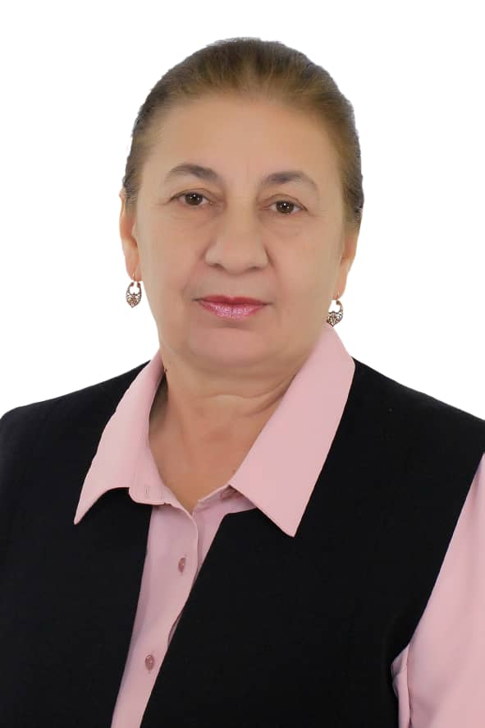
2|52 Anar , Osh, Kyrgyzstan, 714000
Phone (hm) : + 9960322262710
Cell: + 9960772605363
E-mail: Saliya 2007@gmail.com

Personal details
Date of birth: 10 July 1965
Place of birth: Naukat, Kyrgyzstan
Nationality: hemshil
Citizenship: Kyrgyzstan
Gender: Female

SALIYA KOSO – OGLY HAIDAROVNA

Work experiences:

2005- present Osh State University. Faculty of World languages, instructor
Courses: Methods of teaching English Language, Lexics (English language), Literal translation, Annotational translation, Report translation, English grammar , Newspaper, Business English.

1987-1989 The Pushkin school, Naukat, instructor
  - School №9, Jalal – Abad, instructor
1993-1994 Jala l- Abad state University, instructor
Courses: Lexics, Phonetics,(English language)
1994-2001 Turkish High Boys’ School №14 Jalal – Abad, instructor
Courses: Success at first Certificate, WOW, Headway pre-intermediate, Headway new-intermediate
2001-2005 Turkish High Boys’ School «Sema” Osh , instructor
Courses: WOW, Headway pre-intermediate, Headway new-intermediate, reading, writing
Education :

Osh Teachers Training Institute
1982-1987 The faculty of foreign languages.
Major: instructor of foreign languages (English and German)
1972-1982 Secondary school # named after N. K. Krupskaya(Naukat)

Certificates:
British TESOL certificate
1. Professional Level.Imperial English UK. Part A -40h(self-study)
Part B-10h( online workshop)=50h
April 30th 2023

Embassy of the United States of America
Lingua English Language School
A Course on Basic Teacher Training Skills within the Professional English Language Teaching Project
Kyrgyzstan, 2015

Lingua English Language School
Basic Communicative Methodology Course
- a 24 hour training from January 3 to 6, 2014
- a 20 hour practical component from March-May, 2014

AMERICAN ENGLISH INSTITUTE, UNIVERSITY OF
OREGON

Shaping the Way We Teach English,
1: The Landscape of English
Language Teaching
Five-week online teacher training course
May 21, 2014

AMERICAN ENGLISH INSTITUTE, UNIVERSITY OF
OREGON
Shaping the Way We Teach English,
2: Paths to Success in ELT
5-week online teacher training course
June 20, 2014

AMERICAN ENGLISH INSTITUTE, UNIVERSITY OF
OREGON
Critical thinking for English Language Teaching Curriculum
10-week online teacher training course
April 04, 2011 through June 10, 2011

Computer skills:
Microsoft Word, Internet

Language skills:
Fluent in English, Russian, Uzbek, Kyrgyz, Hemshil (native)

Hobby :
reading and traveling

