RESUME

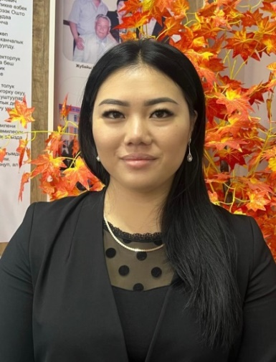
Satanbaeva Meerim Satanbaeva
Osh, Kyrgyzstan, 714000
Phone (hm): + 996559155059
Cell: + 996559155059
E-mail: merima.s1994@gmail.ru

Personal details:
Date of birth: June 2, 1994
Place of birth: Osh, Kyrgyzstan
Nationality: kyrgyz
Citizenship: Kyrgyzstan
Marital status: Married, 2 children
Education :
- 2018 – 2021 Osh State University
Postgraduate Department
Qualification: Philological Education

- 2016-2018 Osh State University
Faculty of World Languages and Cultures
Master’s Department
Qualification: Philological Education
MA degree

- 2011-2016 Osh State University
Faculty of World languages and Cultures
Qualification: Teacher of
Foreign Languages
BA Degree (Diploma with Honors)

- 2011-2013 Osh Technological College
Faculty of Economics and Management
Qualification: Financier

- 2001-2011 School-Gymnasium #5 n.a. J.Bokonbaev

Work experiences:
- 2020 – present
Osh State University, Faculty of World languages, English language instructor
Courses: Practical Course of English Language, Methods of teaching English Language

- 2016-2017
Training Center «Ансар Тайп», English teacher

- 2013-2014
MegaCom «Alfa Telecom», Customer Service Specialist

Certificates:
- Teaching English in the digital world, IELTS Language Training Centre/OSU International Medicаl Faculty, October 14, 2023
- The Scientific-Practical Conference “Achievments in the use of new technologies in teaching foreigh languages”, OSU/FWLC, April 24-29, 2023
- Кыргыз, Англис тилдерин изилдөөдө жана окутууда корпустук лингвистиканын методдорун колдонуу, Кыргыз-Түрк «Манас» университети, 36 саат, Февраль 9-11, 2023
- Seminar by Professor of Lomonosov Moscow State University Marklen Konurbaev , LMSU, January-27, 2023
- The National English Language Teachers Conference “ TESOL Methodology 2022”, KGTESOL/US Embassy, October 28-29, 2022
- The “5th” International Conference on Multi-Disciplinary Research Studies and Education, IFERP, May 26-27, 2022
- Lesson planning for young learners and and how to use exam support materials effectively, Cambridge Assesment English, November-9, 2021
- Формирование результатов обучения и их роль в построении учебного процесса, EdNet, Ноябрь-5, 2021
- Teaching Grammar at B1 and B2 levels, Cambridge Assesment English, November-2, 2021
- The 72-hour of Professional Development Course, OshSU/FWLC, 2021
- Emotional Intelligence and Positive group dynamics, Oxford University Press, March, 2021
- International Qualification for Teachers, UCA, March-5, 2021
- Promoting Creativity in Digital Learning, British Council, February-25, 2021
- Cambridge Assessment English Qualifications Information session, UCA, February-19, 2021
- Using different platforms and electronic educational materials in the foreign language classroom, EDU Press, December 30, 2020
- Илимий-изилдөө иштеринин методологиясы, ОшГУ/Отдел науки и аспирантуры, Июнь 13-15, 2019
Research:
Scientific research theme: «Linguocultural specificity of the representation of the concept “Teacher” in English and Kyrgyz languages» (10.02.20)
Publications:
- «Comparative Analysis of "Teacher" Concept in English and Kyrgyz Literature», Наука.Образование.Техника – Ош, №3, 2023

- «Аспекты применения концепта «Учитель» в кыргызско англоязычной картине мира», Bulletin of Science and Practice, Нижневартовск, Т. 9. №6. 2023 – С.704-709. eISSN: 2414-2948. https://doi.org/10.33619/2414-2948/91/90

- «Языковые средства, репрезентирующие концепт «Учитель» в английском и кыргызском языках», International Journal of Humanities and Natural Sciences, Новосибирск, № 3-2 (78), 2023 – С.79-83. ISSN: 2500-1086. DOI:10.24412/2500-1000-2023-3-2-79-83 http://intjournal.ru/wp-content/uploads/2023/04/Satanbaeva.pdf

- «Potrayal of women in Kyrgyz and American literature is as a reveal of linguaethnic culture», Journal of Pharmaceutical Negative Results, Volume 13, Special Issue 7, 2022. ISSN:2229-7723. DOI:10.47750/pnr.2022.13.S07.296 https://www.pnrjournal.com/index.php/home/article/view/4894

- «Активизация самостоятельной работы студентов в учебном процессе модульно-рейтинговой системе в высших учебных заведениях», ВЕСТНИК- ОГПИ Специальный выпуск , Ош, 2018 – С.236-240. ISSN1694-6359. https://ilim.oshmpu.kg/index.php/01/issue/view/16/31
Computer skills:
- Microsoft Office (Word, Excel, Power Point), Internet
- Driving License: Category B
Language skills:
- Native - Kyrgyz
- Fluent - English, Russian
- Basic knowledge - Uzbek
Hobbies:
- Reading, painting, yoga and traveling

