HARMONEE
HARMONEE

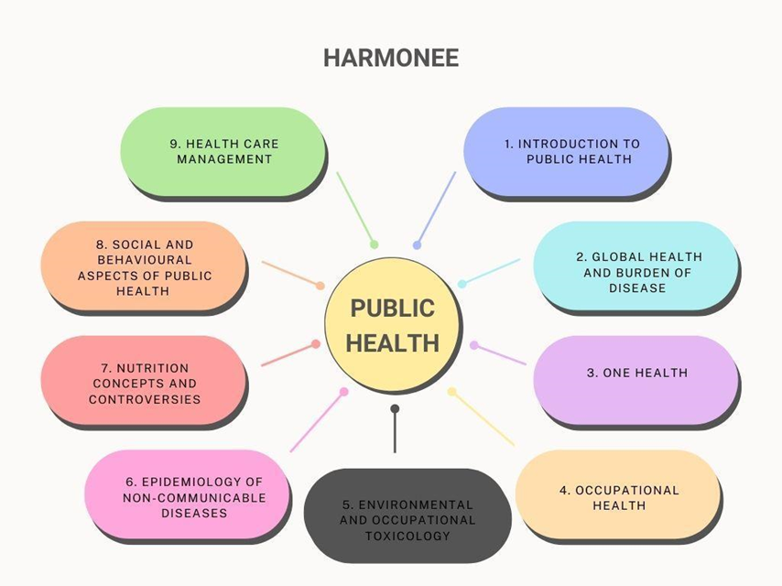

MINISTRY OF EDUCATION AND SCIENCE OF THE KYRGYZ REPUBLIC

OSH STATE UNIVERSITY

"Approved"

At the meeting of the department __________________________

Protocol No. ______ dated "______" __________ 20___

Head of Department __________________________

"______" _______________________ 20____

STUDENT PROGRAM

(SYLLABUS)

Course name | Lecturer | office hours |  |  | Contact Information
"Fundamentals of management of healthcare organizations" | Candidate of Medical Sciences, Associate Professor Muydinov F.F.tel. (996)_552272652___________ | lecture | seminar | Self work | department  ______________  ______-cabinet  ___00 -___00
 |  | 12 ac. | 18 a.h. | 30 a.h.

Credit - 2
Semester-I
Reporting- exam
Form of study:full-time

The syllabus is compiled on the basis of_____________________________________________

_______________________________________________________________________________________________________________________________________________________________________________________________________________________________________

Osh city, 20_____

Aims of the discipline

The purpose of teaching is to master the theoretical knowledge of undergraduates, they must know the theoretical and methodological foundations of management in modern conditions of healthcare management. in the formation of professional skills in the field of healthcare management, as well as the goal of the program is to give undergraduates an understanding of the subject "Introduction to healthcare management", to promote personal and professional self-development of undergraduates.
Formation of universal, general scientific and professional competencies of the master"560100 - Public Health" Andeducation of his professional and personal qualities on the basis of systemic knowledge and ideas in the field of management in health care.

Tasks:
- To get acquainted with the basic concepts, general principles and laws of modern management;
- To study the basic principles of a systematic approach to management in health care;
- Master the skills of business communications;
- To study the basic functions of management.

The place of the course in the structure of the BEP HPE
Discipline"Introduction to Health Management" refers to the general scientific cycle of disciplines O3. 2 Management in health care is the science of managing, regulating and controlling the financial, material and human resources of medicine. Target"Introduction to Health Management" - it is the science of control and management of resources (human, financial, material) by health authorities. The features of management in health care are the social significance of the results, the difficulty of using quantitative indicators for evaluation, the features of financing, human resources (various professional groups, specialization), management objects, and external factors.
The discipline "Introduction to Health Management" is part of the university component (basic part) of the general scientific cycle of the PEP for the preparation of masters in the direction of "public health". The discipline is one of the competent disciplines. Studying in 1 semester. This discipline is allocated 2 credits, an exam is provided at the end of the semester
Scoring Policy
The control of knowledge and the quality of education aims to evaluate the work of a master student for a semester, the degree of assimilation of theoretical knowledge, to test the skills of independent work, to be able to synthesize the acquired knowledge and apply them in solving practical, professional problems.
For each topic, undergraduates pass current controls. For the purpose of intermediate testing of knowledge of undergraduates, midterm controls are carried out. The total score is 100.

The scale of academic performance is given below:
Rating (points) | Grading by letter system | Evaluation digital equivalent | Assessment according to the traditional system
87-100 | A | 4.0 | Great
80-86 | B | 3.33 | Fine
74-79 | C | 3.0
68-73 | D | 2.33 | Satisfactorily
61-67 | E | 2.0
31-60 | FX | 0 | unsatisfactory
0-30 | F | 0

 | Visit to class | oral questioning | situational  Task | Analysis interpretation | Quiz /PPT | Total
Topic1 | 5 | 10 | 5 | 5 | 5 | thirty
Topic2 | 5 | 10 | 5 | 5 | 5 | thirty
Topic3 | 5 | 10 | 5 | 5 | 5 | thirty
Topic4 | 5 | 10 | 5 | 5 | 5 | thirty
Topic5 | 5 | 10 | 5 | 5 | 5 | thirty
Topic6 | 5 | 10 | 5 | 5 | 5 | thirty
Theme 7 | 5 | 10 | 5 | 5 | 5 | thirty
Theme 8 | 5 | 10 | 5 | 5 | 5 | thirty
Theme 9 | 5 | 10 | 5 | 5 | 5 | thirty
 |  |  |  |  |  | (NT/9)=30

Course policy.
Student Requirements
1. Do not miss all types of classes without good reason;

2. Activity during practical classes;

3. Preparation for classes;

4. Do not be late for classes;

5. Do not engage in extraneous activities during class;

6. Be tolerant, open and friendly to fellow students and teachers;

7. Carefully treats the property of the department

8. Timely work off classes missed for good reasons.

9. Do not miss lectures without good reason, otherwise the student will be penalized (if you miss 1 lecture without a good reason, the penalty point is 0.66%).

Thematic plan of the lecture material on the discipline "Introduction to Healthcare Management"
No. | Lecture topic | Number of hours
1 | Organizational Behavior and Managerial Thinking | 2
2 | Strategic Planning, Healthcare Marketing | 2
3 | Fundamentals of Quality Improvement, Healthcare and Health Insurance Financing | 2
4 | Cost and income management | 2
5 | Health worker management | 2
6 | Special Topics and Emerging Issues in Health Management | 2

Thematic plan for a practical lesson on the discipline "Introduction to Healthcare Management"

No. | Topics of independent work of undergraduates | Delivery form | Number of hours
1 | Basic concepts and categories of management in  health care | Essay | 3
2 | Development of healthcare systems as an object of management | Analyze the development of health systems | 3
3 | Methodological foundations of management in health care | Case studies | 3
4 | Fundamentals of technology standardization management in health care | Compose a crossword | 3
5 | Healthcare Marketing Management | Case studies | 3
6 | Management of innovative processes in the organization. | Related report | 3
7 | Conditions for the effectiveness of management decisions | Presentation | 3
8 | Change management, organizational culture | Essay | 3
9 | Corporate Social Responsibility Management | Analyze | 3
10 | Socio-psychological methods of management. Self-management | Debate | 3
 | Total: |  | 30 hours

Calendar-thematic plan of Self work

Subject | form of control | Number of hours | Max. score
1. Basic concepts and management categories of management in  healthcare. | debate and case study analysis | 2 | thirty
2. Development of health systems as an object  management | Test tasks | 2 | thirty
3. Methodological foundations of management in  health care | Debate,  Case Study Analysis | 2 | thirty
4. Organization as an object of management  health care | Essay | 2 | thirty
5.Structural and functional foundations  health organization management | Problem Based Learning Case Study | 2 | thirty
6.Communications in the management of the organization | Tasks  Economic logic games (crossword, scanword, puzzles) | 2 | thirty
7. Management decisions in the course of medical  activities. | Debate, inquiry-based learning | 2 | thirty
8. Management and leadership in management  healthcare. | Debate,  Case Studies | 2 | thirty
9.Change management, organizational  Culture | Debate,  Case Study Analysis | 2 | thirty
Total: |  | 18 hours | (NT/9)=30

Learning outcomes (LO) and competencies of a master student, formed in the process of studying the discipline "Fundamentals of management of healthcare organizations"
In the process of mastering the discipline, the undergraduate will achieve the following learning outcomes (LE) and will have the relevant competencies:

General educational program learning outcomes | PLO competencies
LO-5 Capable and ready to plan, organize and administer public health events, develop regulatory, methodological and reporting documentation, as well as to patent work using the principles of healthcare management. | PC-3 Capable and ready to plan, organize and implement measures to ensure the protection of public health

Topic №1 Basic concepts and managerial categories of management in
health care
Control questions:
1. Definition of management in health care: key issues.
2. Changing the role in the organization of healthcare management, medical services.
3. The origin of writing in ancient Sumer.
4. Difficulty in the work of a medical services manager.
5. Historical period of development of management as a science and practice of healthcare
6. Doctors of the Middle Ages al-Farabi, Abu Ali Ibn Sina - Avicenna
7. Management in healthcare
8. Schools of Management
Topic №2 Development of health care systems as an object of management
Control questions:
1. US health care system
2. Health system in Spain
3. French healthcare system
4. Swiss healthcare system
5. Japanese health care system
6. Russian healthcare system
7. The health care system in the Republic of Kyrgyzstan
8. Methods of payment for medical services.
9. Mechanisms for financing the provision of medical care in Kyrgyzstan.
10. Existing healthcare system. Methods of payment for medical services.

Topic №3 Methodological foundations of management in Healthcare
Control questions:
1. The purpose of management in health care.
2. Tasks of the management system
3. Management principles
4. Management functions
5. Economic methods of health care management.

Topic №4 Organization as an object of healthcare management
Control questions:

1. Factors of the external environment.
2. Factors of the internal environment.
3. Signs of the organization as a system.
4. Typology of business organizations.
5. Organization as a legal entity.
6. Methods for analyzing the external and internal environment of the organization.
7.Organization of primary health care facilities (PHC).
8. Analysis of the activities of a medical institution.

Topic №5 Structural and functional foundations of healthcare organization management
1. Definition of the concept of management structure in a medical institution and principles of construction.
2.Methods for the development of management decisions.
3. Management decisions made in the course of medical activities. 4. Demographic indicators.
5. Compare and analyze the stages of making managerial decisions known to you.
6. Why is control over the implementation of the decision needed?

Topic №6 Communication in the management of the organization
Control questions:
1. Give some examples of information exchange at the university.
2. Briefly explain the essence of the main elements of the communication process.
3. Explain the steps in the communication process.
4. Describe the main types of communications.
5. Name the models of social communication.
6. Describe the main barriers to interpersonal communication.
7. Specify ways to overcome barriers in interpersonal communications.
8. What barriers arise in organizational communications?

Topic №7 Management decisions in the course of medical activities.
Control questions:
1. Management decisions in the course of medical activities
2. Need for decision making
3. Decision-making methods
4. Individual decision-making styles
5. Conditions for the effectiveness of management decisions

Topic №8 Management and leadership in healthcare management.
Control questions:

1. The problem of leadership in the theory of traits.
2. Behavioral theories of leadership.
3. Comparative analysis of management and leadership.
4. Situational theories of leadership.
5. Modern approaches to understanding leadership.
6. Features of the concept of charismatic leadership.
7. The essence of the concept of effective leadership.

Topic №9 Change management, organizational culture
Control questions:
1. Change management by organizational culture.
2. Characteristics of external sources of change.
3. Internal sources of change.
4. Classification of the main types of changes.
5. Main objects of change.

Literature on the discipline "Introduction to Health Management"

1. Medic V.A., Public health and healthcare [Electronic resource]:
textbook / Medic V. A., Yuryev V. K. - 2nd ed., corrected. and additional - M.: 2016.
-http://www.studmedlib.ru/book/ISBN9785970437100.html
2. Medical documentation: accounting and reporting forms [Electronic resource] / R.A.Khalfin, E.V. Ohryzko, E.P. Kakorina, V.V. Madyanova - M.: 2014.
-http://www.studmedlib.ru/book/ISBN9785970428740.html
3. Romanov A.,Kevorkov V. Marketing and competitiveness of a medical organization. Publisher: KnoRus, 2013
-https://www.hse.ru/data/2015/08/26/1086401101/pud_marketing-medicinskih-uslug_293965.pdf
4. Funky business: Capital dances to the tune of talent / K.Nordstrom, J. Ridderstrale; per. from English. [P. Pavlovsky] - 3rd ed. - M.: 2013, - 288s.: ill.
- https://www.litmir.co/br/?b=68202
5. Database "Electronic Library of Medical University" Access to the kits "Medicine. Healthcare. IN".
-http://www.studmedlib.ru
6.Electronic Database (DB) Medline Medline complete
-http://search.ebscohost.com
7. Polythematic abstract-bibliographic and scientometric (bibliometric) database Scopus Sublicense agreement No. 1115/Scopus of 01.11.18 DB website: www.scopus.com
8. Polythematic abstract-bibliographic and scientometric (bibliometric) database Web of Science Sub-license agreement No. 1115/WoS of 04/02/18 Database website: http://webofknowledge.com
9. Scientific electronic library Science Index "Russian citation index". A simple non-exclusive license to use the information and analytical system Science Index License agreement SCIENCE INDEX No. SIO-324/2019 dated May 27, 2019 Website of the database: https://elibrary.ru
10. Public health and health care: National leadership / ed. V.I. Starodubova, O.P. Shchepina and others - M.: 2014.
11. Shchepin O.P., Medic V.A. Public health and health care: Textbook. M.: 2012.
12. Management in health care: Proc. allowance / Ed. MM. Mukhambekov. M.: 2012.
13. Management and economics of health care: textbook for universities / ed. A. I. Vyalkova. -3rd ed., add. -Moscow 2013.
14. Rakhypbekov P.Kh. Financial management in health care: Proc. allowance. M.: 2012.
15. Shemetov P.V., Cherednikova L.E., Petukhova S.V. Management: management of organizational systems: Proc. allowance. M.: 2012.
16. Beck Don Edward, Cowan Christopher K. Spiral Dynamics. Driving values, leadership and change in the 21st century. BestBusinessBooks, Open World: 2010.
17. Knyazyuk N.F., Kitsul I.S. Methodology for building an integrated management system for medical organizations. M.: Publishing House "Health Manager". 2013.
18. Covey Stephen R. Leadership based on principles. Alpina Publisher.: 2019.
19. Kotler F., Keller K.L. Marketing management. St. Petersburg: Peter, 2009.
20.Krivenko N.V. Problems management organizational and economic changes in healthcare institutions. Yekaterinburg: Institute of EconomicsUral Branch of the Russian Academy of Sciences, 2012.
21. Kurakova N.G., Zinov V.G., Tsvetkova L.A.,Kurakov F.A. Management of innovative projects in sphere healthcare. M.: Publishing House "Health Manager", 2011.

