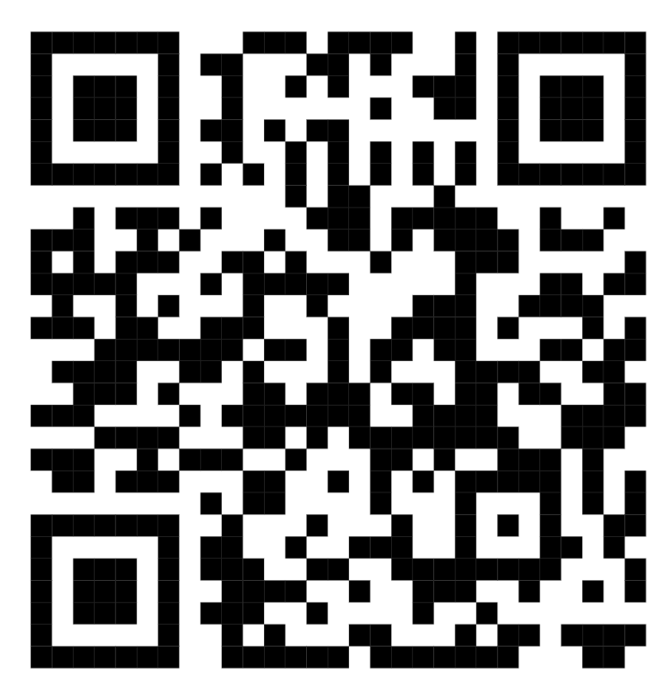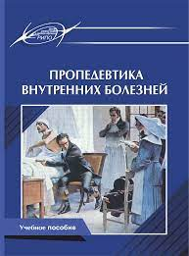https://znanium.ru/read?id=367798

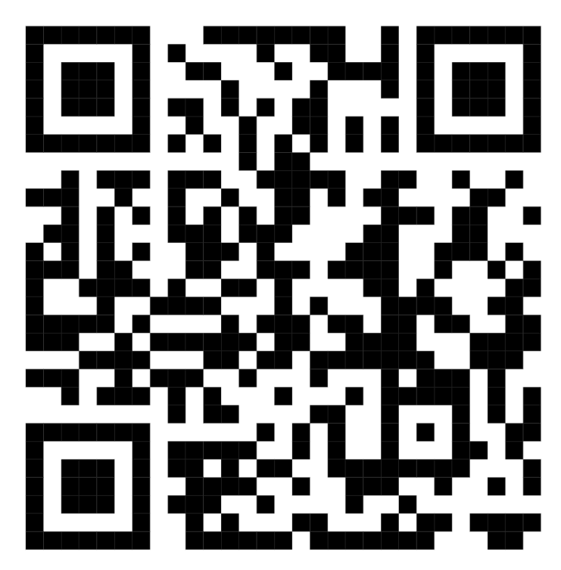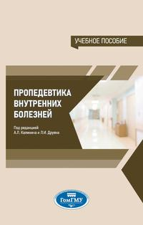

https://znanium.ru/catalog/document?id=454708

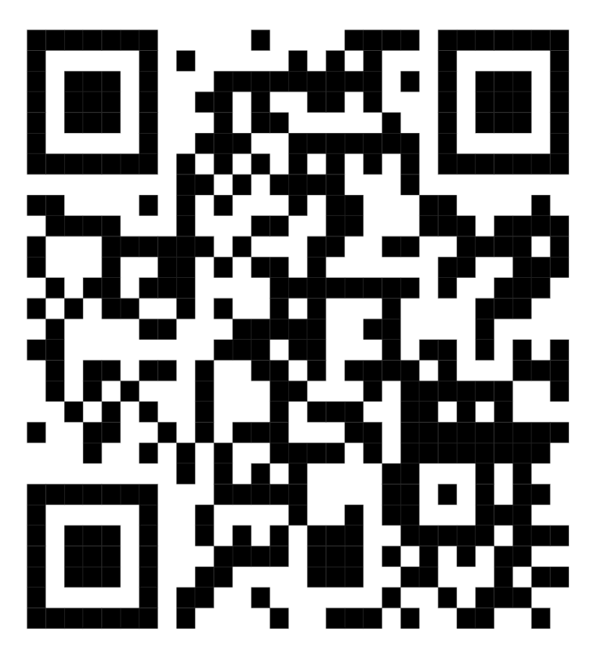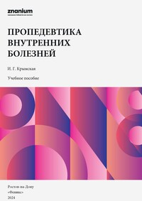

https://znanium.ru/catalog/document?id=444874

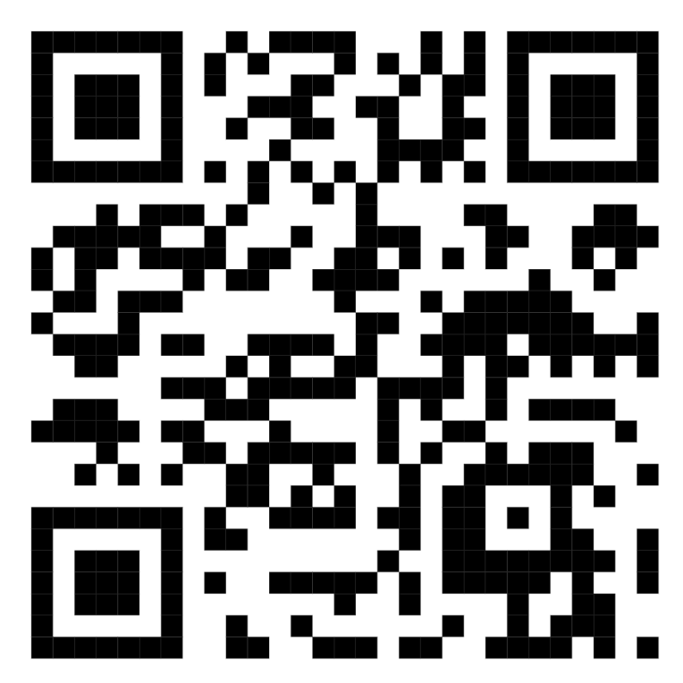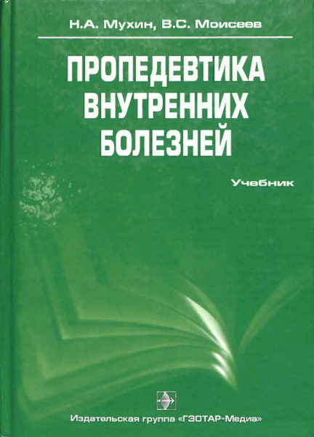

https://e-library.sammu.uz/uploads/books/Rus%20tilidagi%20adabiyotlar/%D0%A1%D1%83%D0%B4%D0%B5%D0%B1%D0%BD%D0%B0%D1%8F%20%D0%BC%D0%B5%D0%B4%D0%B8%D1%86%D0%B8%D0%BD%D0%B0/%D0%9F%D1%80%D0%BE%D0%BF%D0%B5%D0%B4%D0%B5%D0%B2%D1%82%D0%B8%D0%BA%D0%B0_%D0%B2%D0%BD%D1%83%D1%82%D1%80%D0%B5%D0%BD%D0%BD%D0%B8%D1%85_%D0%B1%D0%BE%D0%BB%D0%B5%D0%B7%D0%BD%D0%B5%D0%B9_%D0%9C%D1%83%D1%85%D0%B8%D0%BD_%D0%9D_%D0%90_2012.pdf

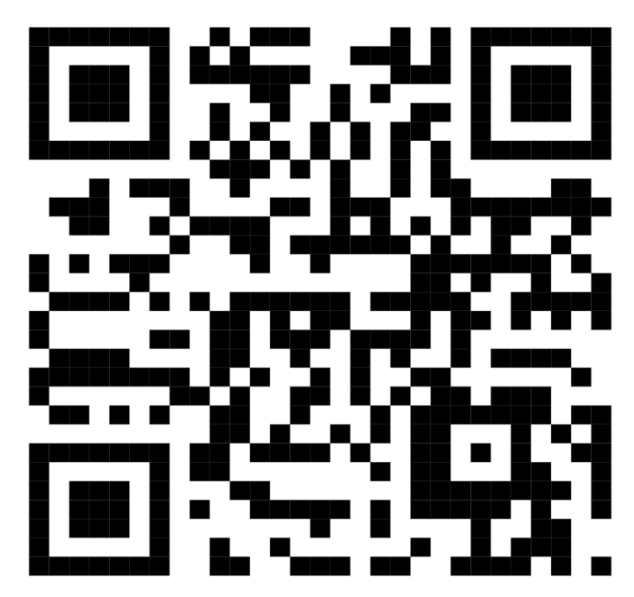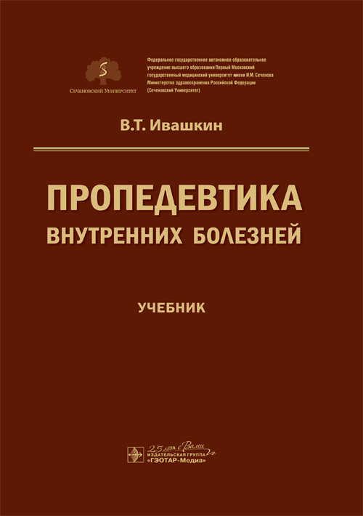

https://www.studentlibrary.ru/book/ISBN9785970456989.html

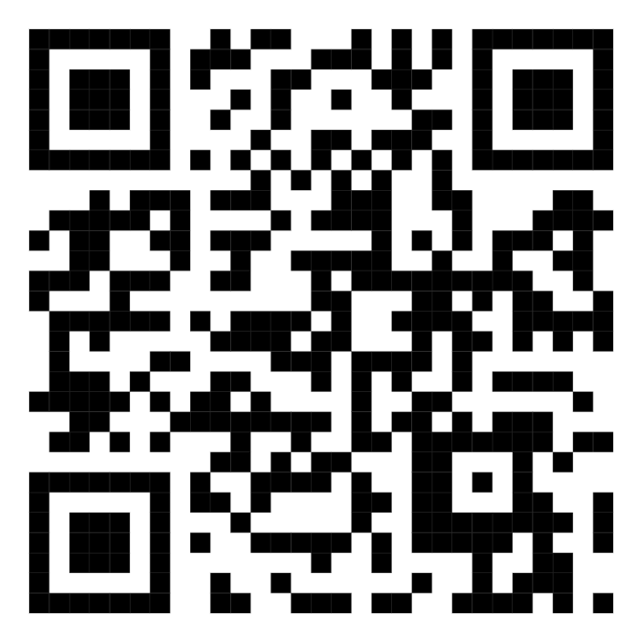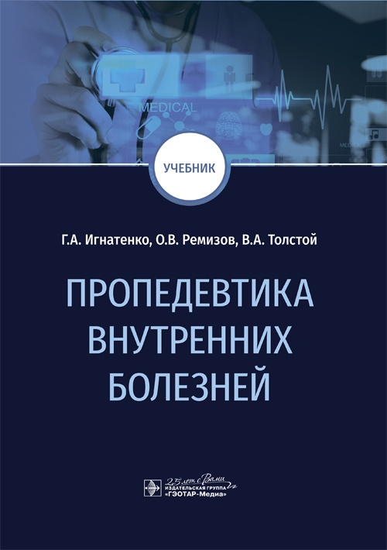

https://www.studentlibrary.ru/book/ISBN9785970458273.html

